Test Case: tc001_SPX_Dev5_Crear_Solicitud_Articulo_Almacen
Step 1 - Enter username and password and click to button Enter : Credentials Entered
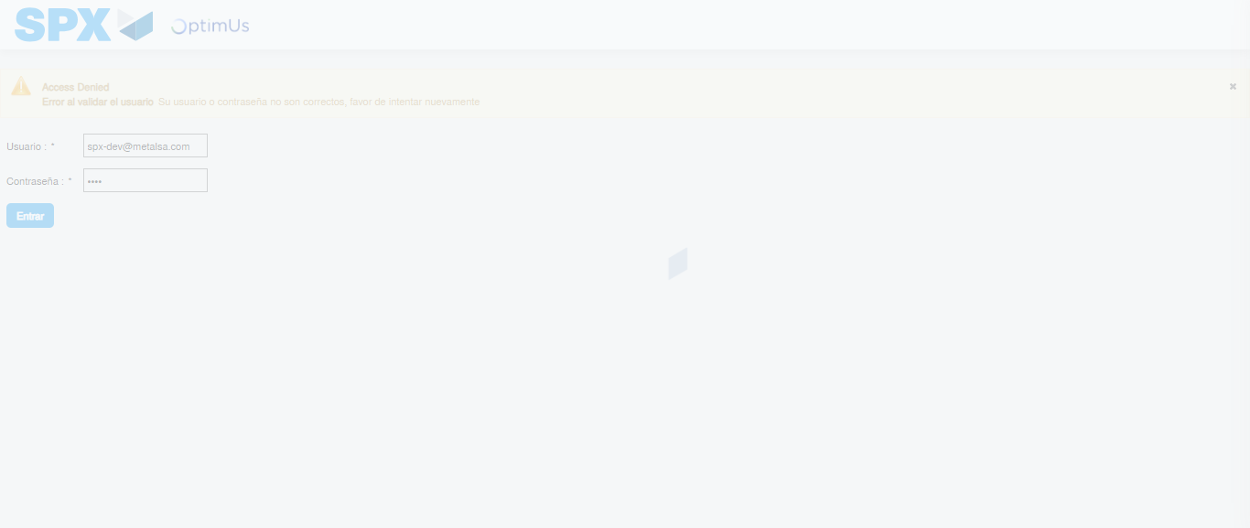Image file-name: QC_Testing-tc001_SPX_Dev5_Crear_Solicitud_Articulo_Almacen-1787939456983

Step 2 - Select to UEN and Access to Request for a New Inventory Item : UEN Correctly selected and Correct access
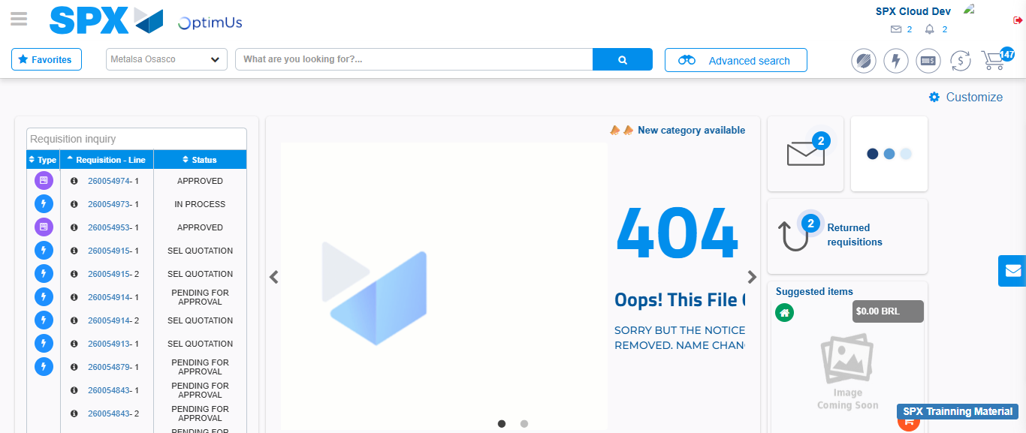Image file-name: QC_Testing-tc001_SPX_Dev5_Crear_Solicitud_Articulo_Almacen-1787939484280

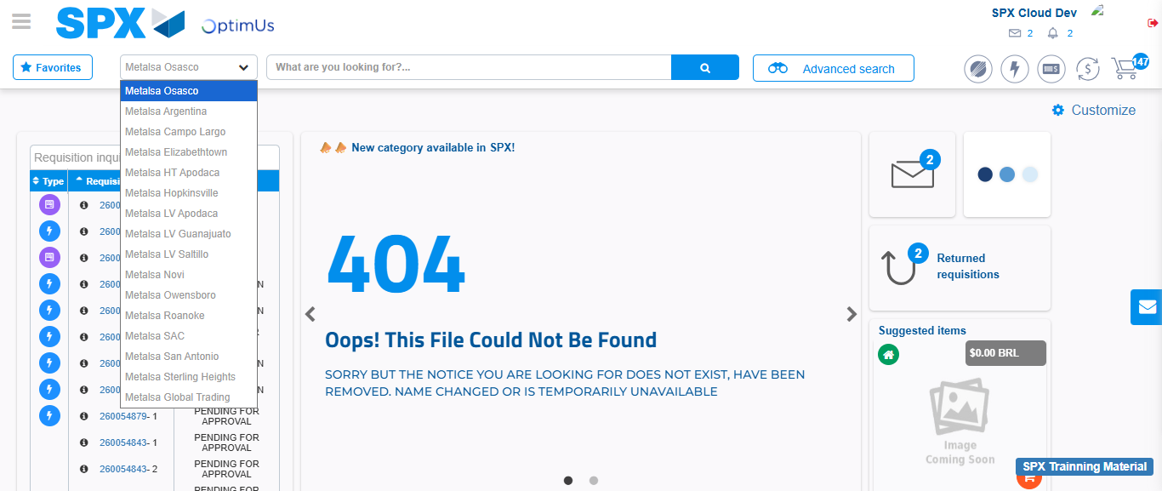Image file-name: QC_Testing-tc001_SPX_Dev5_Crear_Solicitud_Articulo_Almacen-1787939484826

Image file-name: QC_Testing-tc001_SPX_Dev5_Crear_Solicitud_Articulo_Almacen-1787939513519

Step 3 - Select options first section : Options seleted correctly
Image file-name: QC_Testing-tc001_SPX_Dev5_Crear_Solicitud_Articulo_Almacen-1787939513760

Image file-name: QC_Testing-tc001_SPX_Dev5_Crear_Solicitud_Articulo_Almacen-1787939513926

Step 4 - Select options at Screen: Options seleted correctly
Image file-name: QC_Testing-tc001_SPX_Dev5_Crear_Solicitud_Articulo_Almacen-1787939513760

Image file-name: QC_Testing-tc001_SPX_Dev5_Crear_Solicitud_Articulo_Almacen-1787939513926

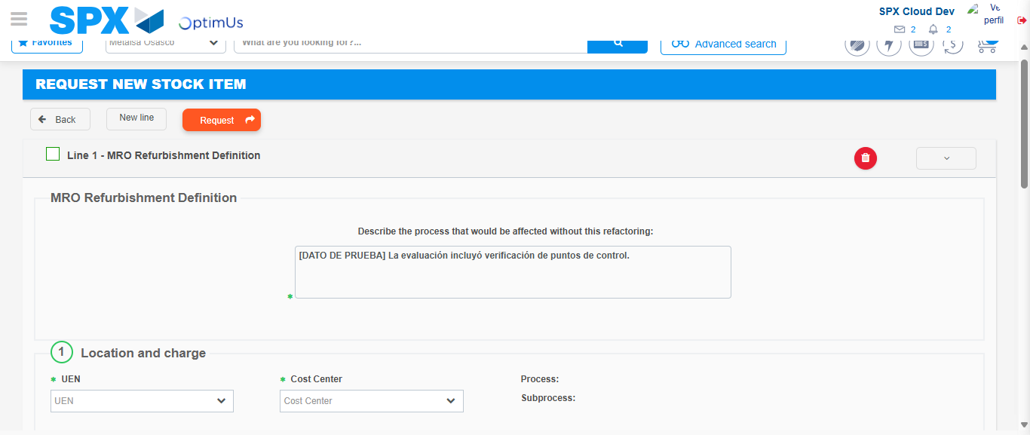Image file-name: QC_Testing-tc001_SPX_Dev5_Crear_Solicitud_Articulo_Almacen-1787939524754

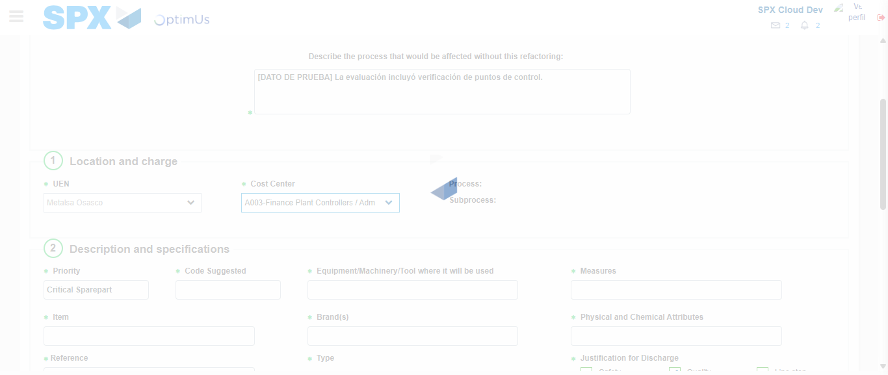Image file-name: QC_Testing-tc001_SPX_Dev5_Crear_Solicitud_Articulo_Almacen-1787939527162

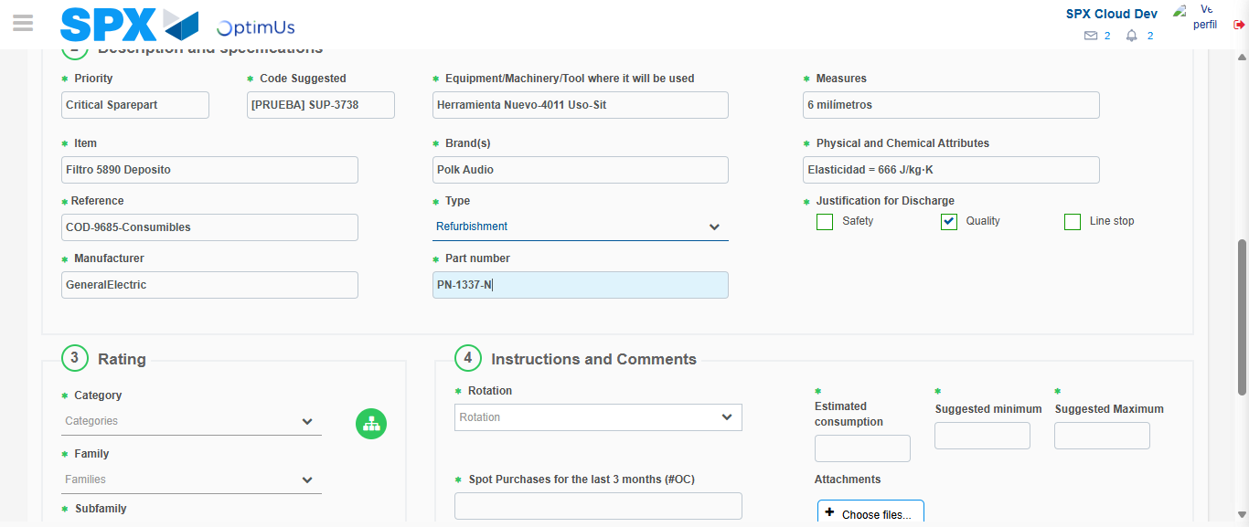Image file-name: QC_Testing-tc001_SPX_Dev5_Crear_Solicitud_Articulo_Almacen-1787939528347

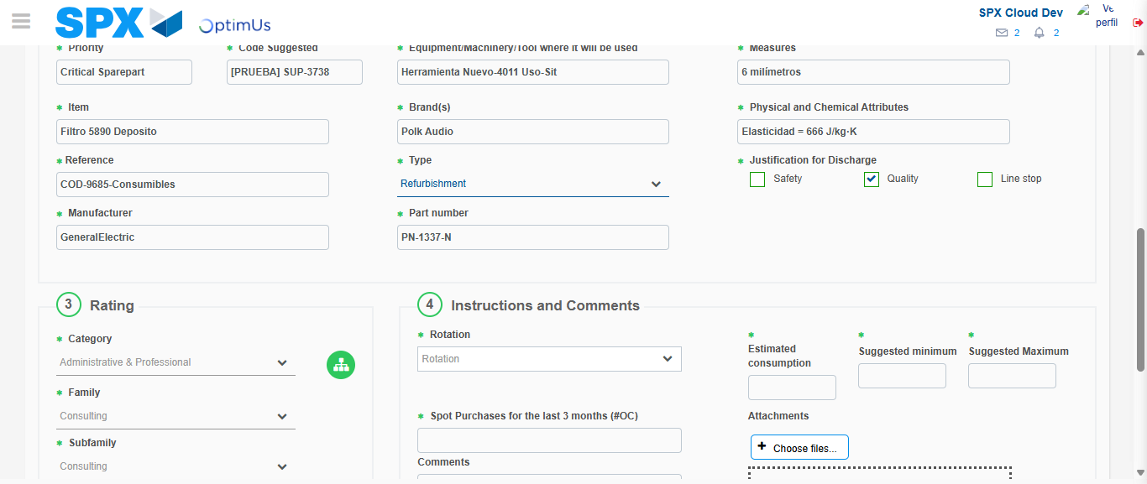Image file-name: QC_Testing-tc001_SPX_Dev5_Crear_Solicitud_Articulo_Almacen-1787939532268

Step 5 - Request New Item : Request Accepted
Image file-name: QC_Testing-tc001_SPX_Dev5_Crear_Solicitud_Articulo_Almacen-1787939484280

Image file-name: QC_Testing-tc001_SPX_Dev5_Crear_Solicitud_Articulo_Almacen-1787939484826

Image file-name: QC_Testing-tc001_SPX_Dev5_Crear_Solicitud_Articulo_Almacen-1787939513519

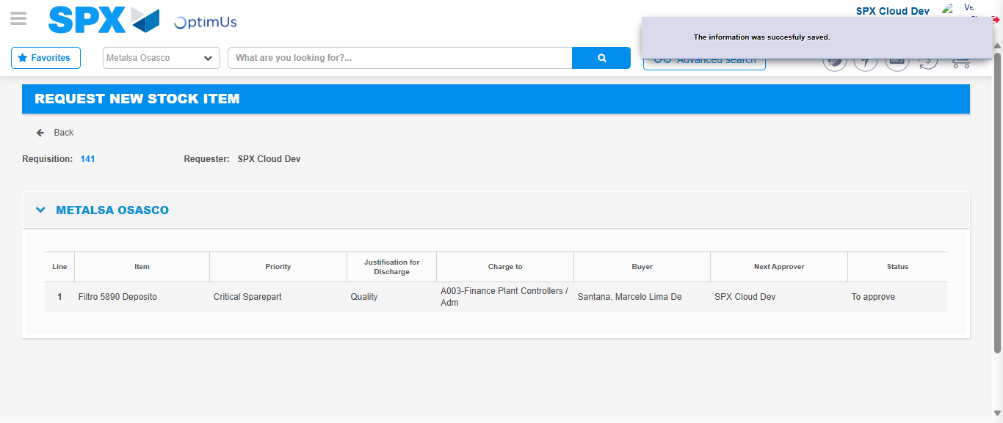Image file-name: QC_Testing-tc001_SPX_Dev5_Crear_Solicitud_Articulo_Almacen-1787939538669

Image file-name: QC_Testing-tc001_SPX_Dev5_Crear_Solicitud_Articulo_Almacen-1787939538851

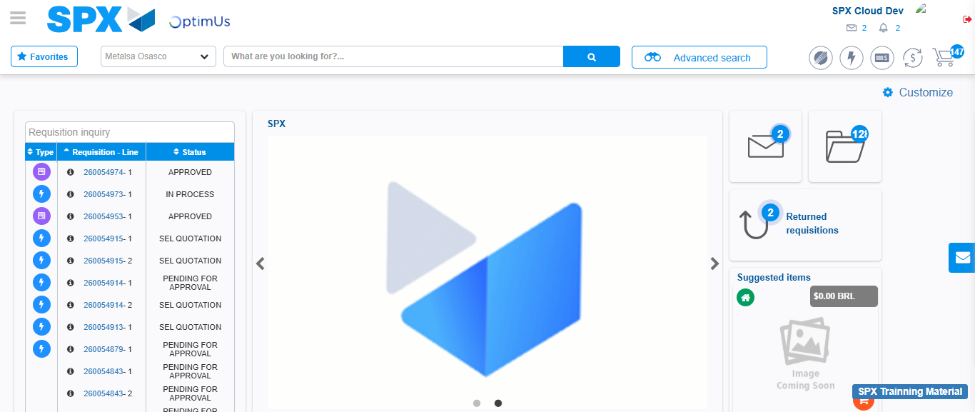Image file-name: QC_Testing-tc001_SPX_Dev5_Crear_Solicitud_Articulo_Almacen-1787939559947

Step 7 - Return to Main Page SPX : Return to Main Page SPX
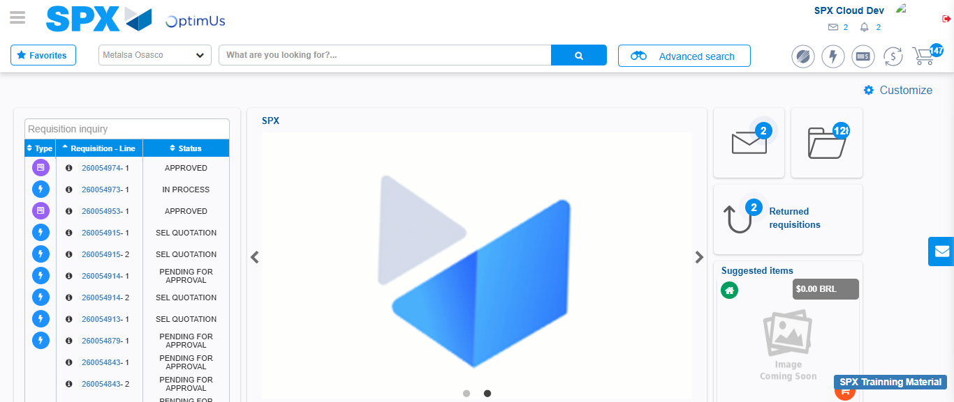Image file-name: QC_Testing-tc001_SPX_Dev5_Crear_Solicitud_Articulo_Almacen-1787939560197

